1. **Git URL** – [vasanthkalai/hello-world: Week 1 - Assignment (github.com)](https://github.com/vasanthkalai/hello-world)
2. **What is the level of measurement of the following variables?**

Nominal variables – names or types.

Ordinal variables – ordered data.

Ratio – values with true zero.

1. The number of downloads of different bands' songs on iTunes – Ratio.
2. The names of the bands that were downloaded – Nominal variable.
3. The position in the iTunes download chart – Ordinal variable.
4. The money earned by the bands from the downloads – Ratio.
5. The weight of drugs bought by the bands with their royalties – Ratio.
6. The type of drugs bought by the bands with their royalties – Nominal variable.
7. The phone numbers that the bands obtained because of their fame – Nominal variable.
8. The gender of the people giving the bands their phone numbers – Nominal variable.
9. The instruments played by the band members – Nominal variable.
10. The time they had spent learning to play their instruments – Ratio.
11. **Say I own 857 CDs. My friend has written a computer program that uses a webcam to scan the shelves in my house where I keep my CDs and measure how many I have. His program says that I have 863 CDs. Define measurement error. What is the measurement error in my friend's CD-counting device?**

Measurement error = measured value – true value

Thus, measurement error = 863-857=6

1. **Sketch the shape of a normal distribution, a positively skewed distribution and a negatively skewed distribution.**

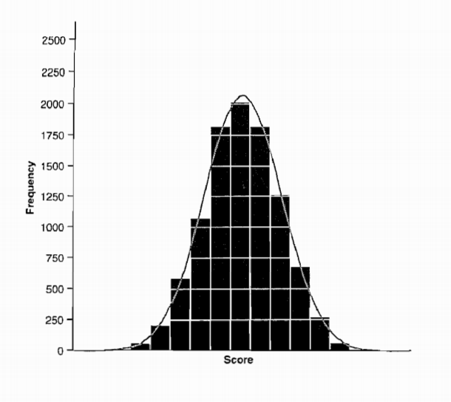

**Normal Distribution**

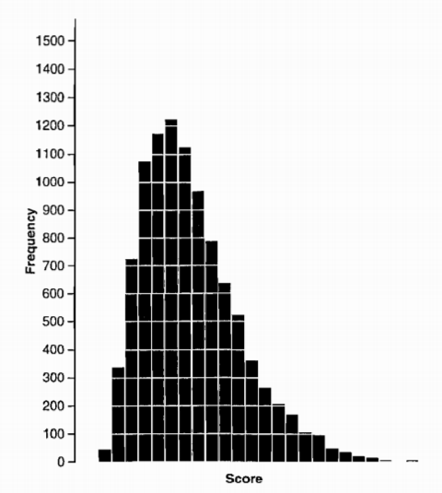

**Positively skewed distribution**

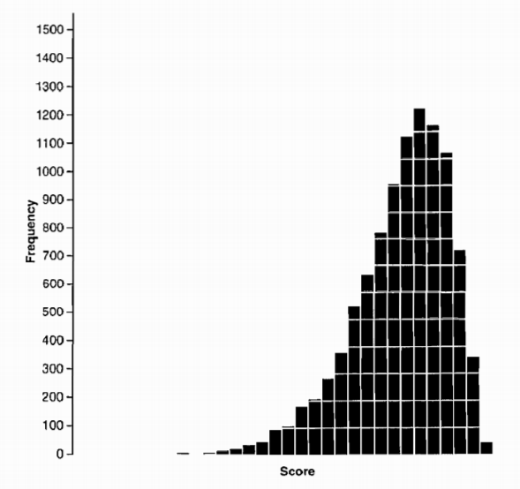

**Negatively skewed distribution**